SIMATS ENGINEERING (SAVEETHA SCHOOL OF ENGINEERING)

Department of Computer Science and Engineering

CO1 ASSESSMENT TOOL 1 – Case Study Analysis

Course Code: | CSA10 / CSA1024 | Course Title: | Software Engineering
CO Assessed: | CO1 | Assessment: | Assessment Tool 1 – Case Study Analysis
Weightage: | 20% | Total Marks: | 25
CO1 Statement: | Apply advanced methodologies and agile project management techniques to manage software projects effectively
Student Name: | KISHORE A | Reg. No.: | 192521467
Date: | 11/10/2026 | Duration: | 60 minutes
Code of Conduct
I KISHORE A (Name / Reg No) certify that this submission is my original work and that I have adhered to the guidelines specified for this assessment. I understand that any violation of academic integrity rules will result in disciplinary action.
Signature of the Student:
Annexure A – Case Study Analysis

Instructions to Students:
Each student will be allotted one problem statement. Analyze the assigned problem systematically by following the steps given below. Your report should demonstrate your understanding of software engineering concepts and your ability to design an appropriate software solution.
Based on your allotted problem statement, prepare a report by answering the following questions:

Understand the Problem Statement
  - Explain the problem in your own words.
  - Identify the objectives of the proposed system.
  - State the scope of the problem.

Identify Key Stakeholders and Challenges
  - Identify all the stakeholders involved in the system.
  - Explain the roles and responsibilities of each stakeholder.
  - Discuss the major challenges and issues faced by the stakeholders.

Analyze the Current Approach
  - Describe the existing system or current process.
  - Identify its strengths and limitations.
  - Analyze the problems or gaps that need to be addressed.

Propose a Suitable Solution Using Software Engineering Principles
  - Design a software-based solution for the given problem.
  - Describe the major functional modules of the proposed system.
  - Identify the functional and non-functional requirements.
  - Explain how software engineering principles such as modularity, scalability, maintainability, reliability, usability, and security are incorporated into your solution.

Justify the Chosen Methodology/Framework
  - Select an appropriate Software Development Life Cycle (SDLC) model or software development framework (e.g., Agile, Scrum, Waterfall, Spiral, DevOps).
  - Justify why the selected methodology/framework is suitable for the proposed system.
  - Explain how it supports successful project development and maintenance.

Discuss Expected Outcomes and Limitations
  - Describe the expected benefits of the proposed solution.
  - Explain how the solution addresses the identified challenges.
  - Discuss potential risks, implementation challenges, and limitations.
  - Suggest possible future enhancements.

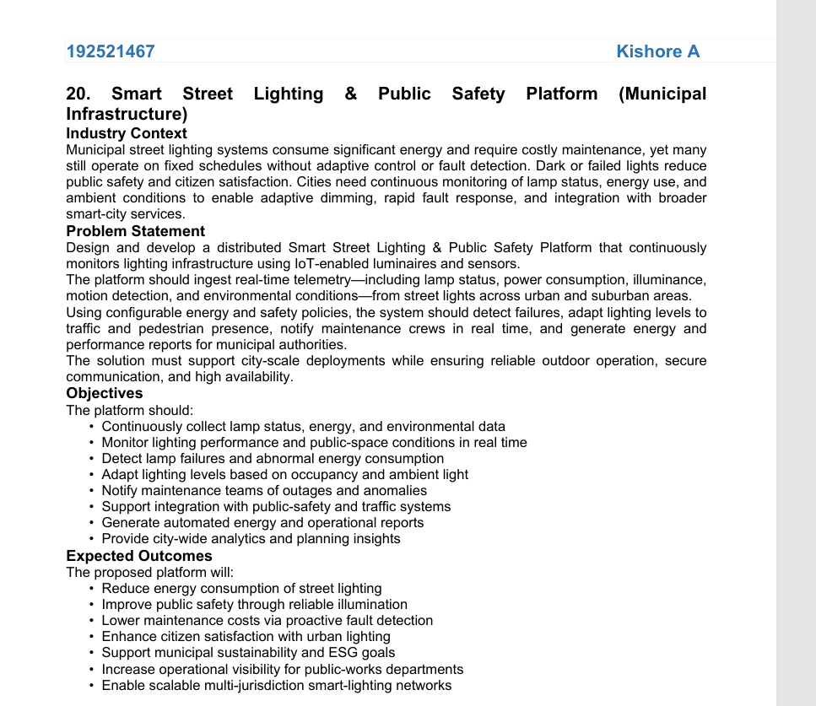

The proposed solution is an IoT-based smart street lighting system that automatically adjusts streetlight brightness, detects faults, monitors public-space conditions, and alerts maintenance teams in real time.
1. Proposed System Architecture
Layer 1: IoT Sensors and Smart Streetlights
Light sensors (LDR), motion sensors (PIR), power sensors, lamp status sensors, and environmental sensors
Layer 2: Communication Network
LoRaWAN, Wi-Fi, or NB-IoT sends sensor readings to the server using MQTT or HTTPS
Layer 3: Backend and Processing
Python Flask, MQTT broker, rule engine, fault detection, and energy analytics
Layer 4: Database and Dashboard
MySQL stores sensor readings, streetlight details, alerts, maintenance records, and reports
Layer 5: Smart Control and Public Safety
Automatic dimming, fault notifications, maintenance management, and municipal analytics
2. Main Modules
Module | Function
Smart Lighting Control | Adjusts brightness based on ambient light and pedestrian or vehicle movement.
Real-Time Monitoring | Displays lamp status, power consumption, brightness, and sensor readings.
Fault Detection | Identifies failed lamps, abnormal power consumption, and communication failures.
Alert Management | Sends notifications to maintenance workers when faults are detected.
Public Safety Monitoring | Identifies poorly illuminated areas and detects unusual environmental conditions.
Energy Analytics | Calculates energy consumption and compares usage before and after optimization.
Municipal Dashboard | Displays streetlight locations, faults, energy reports, and maintenance status.
3. Working Algorithm
- Start the system and connect all IoT streetlights to the network.
- Collect real-time data from light, motion, power, and environmental sensors.
- Send sensor readings to the backend through MQTT.
- Check the ambient light level and motion status.
- Adjust streetlight brightness according to predefined rules.
- Compare lamp status and power readings with expected values.
- If a lamp failure or abnormal energy usage is detected, generate an alert.
- Store readings, alerts, and maintenance records in MySQL.
- Display real-time information and energy reports on the municipal dashboard.
- Repeat continuously.
4. Example Smart Lighting Rules
Condition | System action
Daytime with sufficient natural light | Keep streetlights off, where appropriate.
Nighttime with no detected movement | Dim lights to a safe preset level.
Pedestrian or vehicle detected | Increase brightness in the relevant area.
Lamp failure detected | Notify the maintenance team.
Abnormal power consumption | Generate an energy anomaly alert.
Communication failure | Mark the device as offline and raise an alert.
Safety requirement: Minimum illumination levels must follow applicable municipal standards. Lights should not be dimmed below safe levels, and critical lighting should have a suitable fallback mode.

5. Technology Stack
Component | Suggested technology
Frontend | HTML, CSS, JavaScript
Backend | Python Flask
Database | MySQL
IoT controller | ESP32
Sensors | LDR, PIR, power sensor
Communication | MQTT, Wi-Fi or LoRaWAN
Map integration | Leaflet with OpenStreetMap
Charts and analytics | Chart.js
Notifications | Email or SMS API
6. Expected Results
- Reduced electricity consumption through adaptive lighting.
- Faster detection and repair of defective streetlights.
- Improved visibility for pedestrians and road users.
- Reduced manual inspection and maintenance expenses.
- Centralized monitoring of streetlights across multiple areas.
- Automatic reports for municipal authorities.
- Scalable infrastructure for smart-city development.
7. Conclusion
The Smart Street Lighting and Public Safety Platform combines IoT sensors, automated lighting control, real-time fault detection, and a centralized dashboard. It helps municipalities manage streetlights efficiently, reduce unnecessary energy consumption, and improve public safety. The system can initially be implemented as a small prototype using ESP32, sensors, Python Flask, and MySQL, then expanded to city-wide deployment.
Recommended demonstration: Build a prototype with one ESP32, an LDR, a PIR sensor, and an LED representing a streetlight. Use a web dashboard to display brightness, motion detection, energy readings, and fault alerts. This demonstrates the core solution without requiring a full municipal installation.

Rubrics for Calculation
Criteria | Excellent (5 Marks) | Good (3 Marks) | Satisfactory (2 Marks) | Needs Improvement (1 Mark)
Problem Understanding (30%) | Clearly explains the problem, objectives, and scope with complete understanding. | Explains the problem with minor omissions. | Basic understanding with limited explanation. | Poor understanding; objectives and scope are unclear or missing.
Stakeholder & Challenge Analysis (25%) | Identifies all stakeholders, their roles, and challenges with clear analysis. | Identifies most stakeholders and challenges with adequate analysis. | Identifies only a few stakeholders or challenges. | Stakeholders and system analysis are incomplete or inaccurate.
Current System Analysis (20%) | Thoroughly analyzes the existing system, strengths, weaknesses, and identifies all gaps. | Good analysis with most strengths and weaknesses identified. | Limited analysis with partial identification of issues. | Proposed solution is unclear or inappropriate; requirements are largely missing.
Proposed Software Solution & Software Engineering Principles (15%) | Proposes an innovative, feasible solution applying appropriate software engineering principles (modularity, scalability, maintainability, security, etc.). | Suitable solution with good application of software engineering principles. | Basic solution with limited application of software engineering principles. | Methodology is inappropriate, poorly justified, or not discussed.
Methodology/ Framework Justification (10%) | Selects the most suitable SDLC/model/framew ork and provides strong technical justification. | Suitable methodology selected with adequate justification. | Methodology selected but justification is weak. | Outcomes, limitations, or future enhancements are missing; report lacks organization and clarity.

Criteria | Mark
Problem Understanding (30%) | /5
Stakeholder & Challenge Analysis (25%) | /5
Current System Analysis (20%) | /5
Proposed Software Solution & Software Engineering Principles (15%) | /5
Methodology/ Framework Justification (10%) | /5
TOTAL | /25

